SIT123: Data Capture Technologies

# Lab Report Week 5: Test Motion Sensors for Range and FoV

Today, there are many cheap sensors available on the market, such as passive

Infra-Red (PIR) motion sensors. However, a drawback of these sensors is the inconsistency of their output depending on the manufacturer, and also how they perform differently under various environmental conditions.

## Hardware Required

* Arduino Board
* USB cable
* HCSR505 PIR (Passive Infra Red) Motion Detector
* Bring your laptop with Arduino IDE installed
* A measuring tape
* A protractor

## Software Required

* Arduino IDE

## Pre-requisites: You must do the following before this task

1. **Attend Class (Lecture)**
2. **Read this sheet from top to bottom**

## Task Overview

In this task, you will test the PIR Motion sensor for range and FOV (field of view) and calculate its TPR (true positive rate).

## Task Submission Details

There are 6 questions in this task. Answer all of them in this word document itself and submit to unit site.

Steps:

1. Find some open floor space indoors (around 3 m wide and 1.5 m in height) and mark the floor area as given in the diagram below:

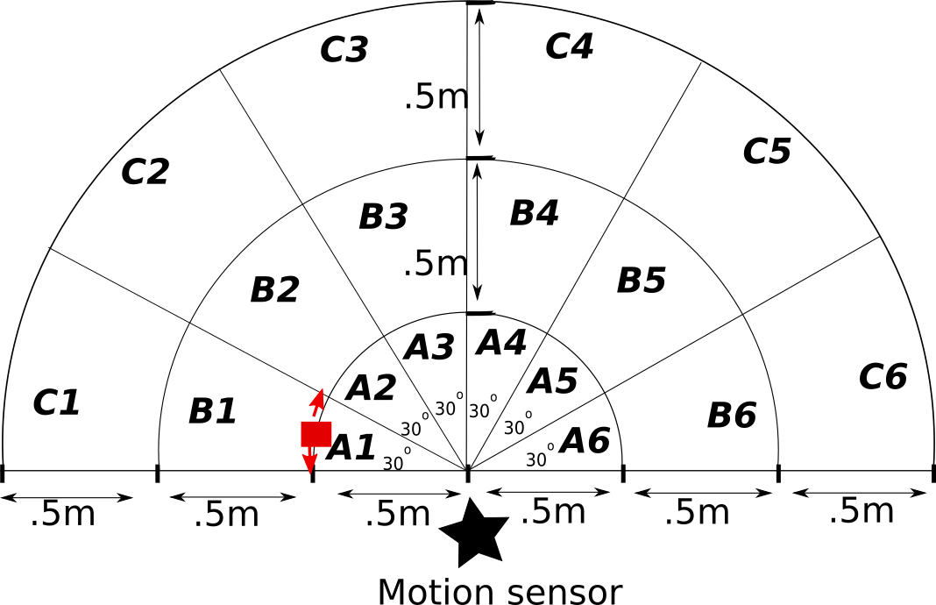

1. Attach the motion sensor to your Arduino board. You can refer to the Task 2.2P instructions on how to do this.
2. Place the motion sensor connected to your computer at the centre as indicated in the diagram.

### **Q1. Recording Active/Inactive States**

We want to find out if the motion sensor can detect movement in each section A1 to A6, B1 to B6 and C1-C6.

* Open the code for motion sensor used in Task 2.2P in your Arduino IDE.
* Ask a friend to step into the edge of section A1 (the red square in the given image) and step sideways bit (look at the red arrows), being careful to stay within the boundaries of A1.
* Check the Serial monitor to see if ‘Active’ states are being recorded. If you can see Active states, mark that in the table below, and then ask your friend to move the next section A2.
* If you can see ‘active’ states when they move to A2, ask your friend to be still for a few seconds until you start seeing ‘Inactive’ states again on the serial monitor, and then ask the friend to step forwards and backwards a bit, being careful to stay within the boundaries of A2. Mark what you see in the table below.
* Repeat this for sections A1 to A6, B1 to B6 and C1-C6.

|  |  |  |  |
| --- | --- | --- | --- |
|  | A | B | C |
| 1 | Active | Active | Active |
| 2 | Active | Active | Active |
| 3 | Active | Active | Active |
| 4 | Active | Active | Active |
| 5 | Active | Active | Active |
| 6 | Active | Active | Active |

### **Q2. Calculate the True Positive Rate at .5 m Range**

1. Enter the motion data you recorded from A1 to A6 in shared file

<https://docs.google.com/spreadsheets/d/1e3n6oo4L-dc3kydQDnt3OX8wOU6hed8v_XALm0Xo3LI/edit?usp=sharing>

If you did the data collection as a group, only enter one reading per group, with all of your names in the relevant cell. Copy the table from the shared file and include here, once there are results from at least 8 groups.

|  |  |  |  |  |  |  |  |
| --- | --- | --- | --- | --- | --- | --- | --- |
|  |  |  |  |  |  |  |  |
| 0 | 1 | 0 | 1 | 1 | 0 | 1 | 1 |
| 1 | 1 | 0 | 1 | 1 | 1 | 1 | 1 |
| 1 | 1 | 1 | 1 | 1 | 1 | 1 | 1 |
| 1 | 1 | 1 | 1 | 1 | 1 | 1 | 1 |
| 1 | 1 | 0 | 1 | 1 | 1 | 1 | 1 |
| 1 | 1 | 0 | 1 | 1 | 0 | 1 | 1 |

b) Use the results from at least 8 groups to calculate the true positive rates for the FoVs given in the table below. You must show the steps of your calculations in the table.

|  |  |
| --- | --- |
| FoV | True positive rate |
| 180° | $$\frac{41}{48}=0.854=85.4\%$$ |
| 120° | $$\frac{30}{32}=0.9375=93.75\%$$ |
| 60° | $$\frac{16}{16}=1=100\%$$ |

### **Q3. Calculate the True Positive Rate at 1 m Range**

1. Enter the motion data you recorded from B1 to B6 in shared file <https://docs.google.com/spreadsheets/d/1e3n6oo4L-dc3kydQDnt3OX8wOU6hed8v_XALm0Xo3LI/edit?usp=sharing>

If you did the data collection as a group, only enter one reading per group, with all of your names in the relevant cell. Copy the table from the shared file and include here once there are results from at least 8 groups.

|  |  |  |  |  |  |  |  |
| --- | --- | --- | --- | --- | --- | --- | --- |
|  |  |  |  |  |  |  |  |
| 1 | 0 | 0 | 1 | 0 | 1 | 1 | 1 |
| 1 | 0 | 1 | 1 | 1 | 1 | 1 | 1 |
| 1 | 1 | 1 | 1 | 1 | 1 | 1 | 1 |
| 1 | 1 | 1 | 1 | 1 | 1 | 1 | 1 |
| 1 | 0 | 1 | 1 | 1 | 1 | 1 | 1 |
| 1 | 0 | 0 | 1 | 1 | 1 | 1 | 0 |
| Ninny Cooke(2020/8/12) | Nathan Johansen (12/08/20) | Harvey Zuccon | John Pouk(12/08/20 | Beau Williams (12/08/20) | Lael Newton + Ben Marriner (12/08/2020) | Matthew Hall (12/08/2020) | Lachlan Burgess (12/08/20) |

b) Use the results from at least 8 groups to calculate the true positive rates for the FoVs given in the table below. You must show the steps of your calculations in the table.

|  |  |
| --- | --- |
| FoV | True positive rate |
| 180° | $$\frac{40}{48}=0.8333=83.33\%$$ |
| 120° | $$\frac{30}{32}=0.9375=93.75\%$$ |
| 60° | $$\frac{16}{16}=1=100\%$$ |

### **Q4. Calculate the True Positive Rate at 1.5 m Range**

1. Enter the motion data you recorded from C1 to C6 in shared file <https://docs.google.com/spreadsheets/d/1e3n6oo4L-dc3kydQDnt3OX8wOU6hed8v_XALm0Xo3LI/edit?usp=sharing>

If you did the data collection as a group, only enter one reading per group, with all of your names in the relevant cell. Copy the table from the shared file and include here once there are results from at least 8 groups.

|  |  |  |  |  |  |  |  |
| --- | --- | --- | --- | --- | --- | --- | --- |
|  |  |  |  |  |  |  |  |
| 0 | 0 | 1 | 0 | 0 | 1 | 0 | 1 |
| 1 | 0 | 1 | 1 | 0 | 1 | 0 | 1 |
| 1 | 0 | 1 | 1 | 1 | 1 | 1 | 1 |
| 1 | 1 | 1 | 1 | 1 | 1 | 1 | 1 |
| 1 | 0 | 1 | 1 | 1 | 1 | 1 | 1 |
| 1 | 0 | 1 | 0 | 0 | 1 | 0 | 0 |
| Harvey Zuccon | Nathan Johansen (12/08/20) | Ninny Cooke(2020/8/12) | John Pouk(12/08/20 | Beau Williams (12/08/20) | Lael Newton + Ben Marriner (18/08/2020) | Matthew Hall (12/08/2020) | Lachlan Burgess (12/08/20) |

b) Use the results from at least 8 groups to calculate the true positive rates for the FoVs given in the table below. You must show the steps of your calculations in the table.

|  |  |
| --- | --- |
| FoV | True positive rate |
| 180° | $$\frac{33}{48}=0.6875=68.75\%$$ |
| 120° | $$\frac{27}{32}=0.8438=84.38\%$$ |
| 60° | $$\frac{15}{16}=0.9375=93.75\%$$ |

### **Q5. Based on the above, what can you say about the range and FoV of the motion sensor tested? Justify your answer, giving reasons.**

Two out of the eight motion sensors have no blind spots at all while the remainder do. This could be due to how the sensor was positioned or if the dials that control the sensitivity and timing were shifted. If the sensitivity dial was adjusted then it may have affected the distance at which movement could be detected. In addition to this, the sensors were better at detecting movement from a narrower range than they were from a wider range and were also the best at detecting movement when the movement was <=50cm away.

### **Q6. Propose an experiment to find the True Negative Rate (TNR) of this sensor.**

Have the sensor placed in an area of the same length and width where there is absolutely nothing that is prone to moving. Have the Arduino record whether there is movement or not every second for 2 minutes. If the sensor detects no movement in the two minutes, the TNR rate would be 100%. If the TNR rate is <100% then either something moved in the area or the sensor has a problem.